60

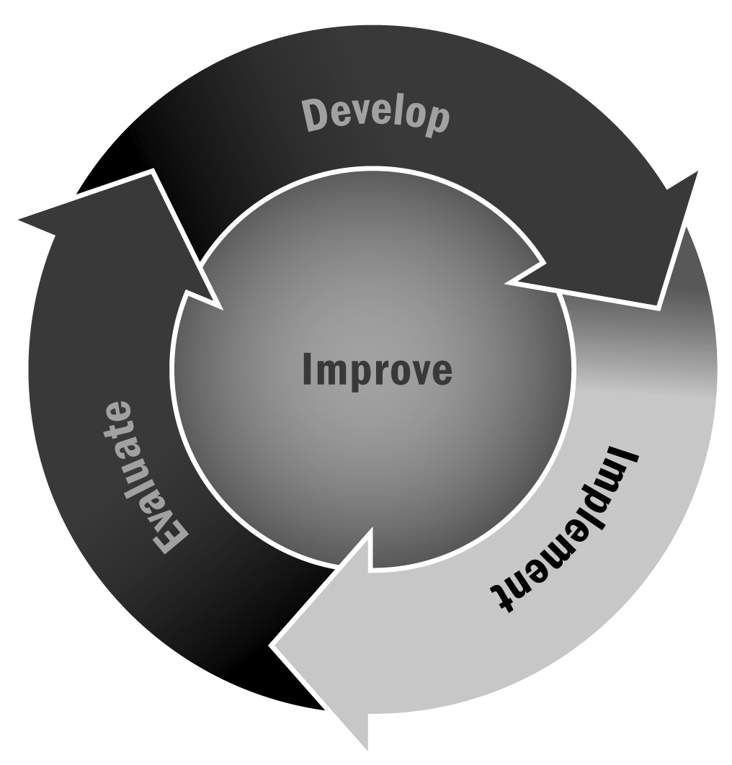
Involving Current and Potential Stakeholders
In Chapter 3, you learned about the importance of developing and maintaining partnerships. There are people who may already be vested in the success of your program and can help by contributing time or resources.
Directions: Use this tool to first brainstorm about all of your current and potential stakeholders (e.g., staff members, volunteers, families, funders, community partners, local politicians, and community groups). Refer back to your asset map (Tool 34), needs assessment (Tool 35), and market analysis (Tool 15) for more ideas about who to include here. Then record how they can and do benefit from, as well as contribute to, your afterschool and expanded learning program. When you can clearly spell out the benefits of working with your program, stakeholders will be much more likely to want to participate. Think about how you might encourage them to take their involvement or contribution to the next level.

Stakeholder | What can they offer your program?  (Think about what they have offered in the past and how they could take their involvement to the next level.) | How might they benefit from the partnership?  (Consider the stake they may have in preparing youth and how your program can help them meet this goal.)
Example:  A local business that provides $1,000 in funding to your program each year. | Example:  Businesspeople could volunteer as guest speakers to talk about how their business is connected to the community or about their experiences visiting or working in other countries. | Example:  Your program helps educate a future community workforce that will know how the company works and has been exposed to information about other countries where the company works.

